Screenshot 1: Submit screenshots of a Bootstrap-powered VueJS app running with Activities 1-6 completed.
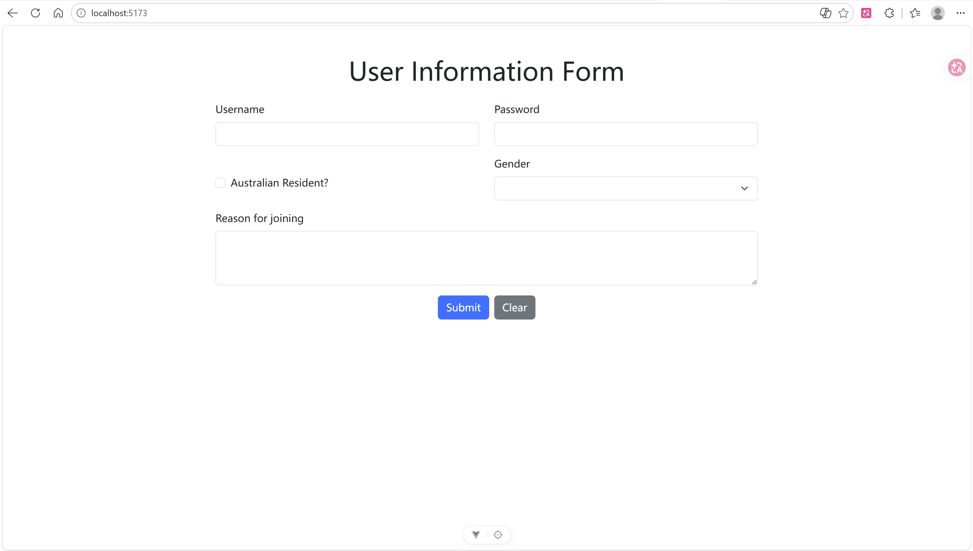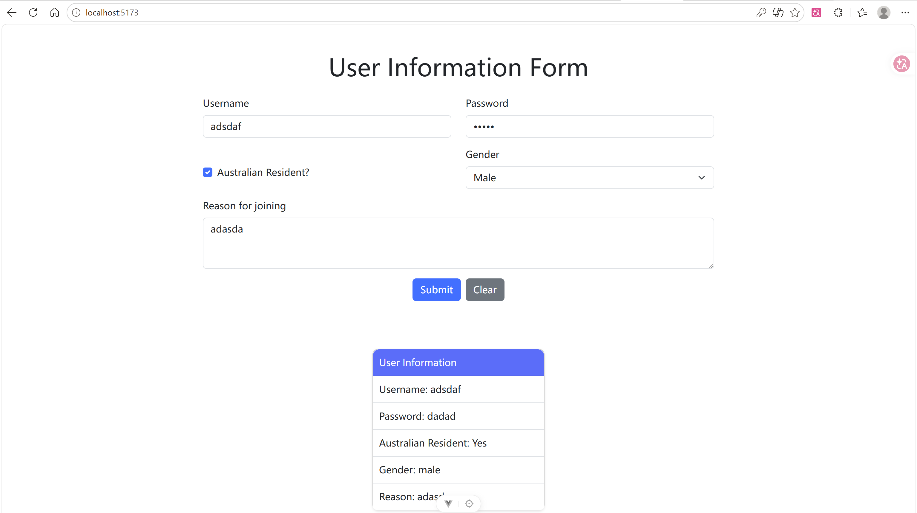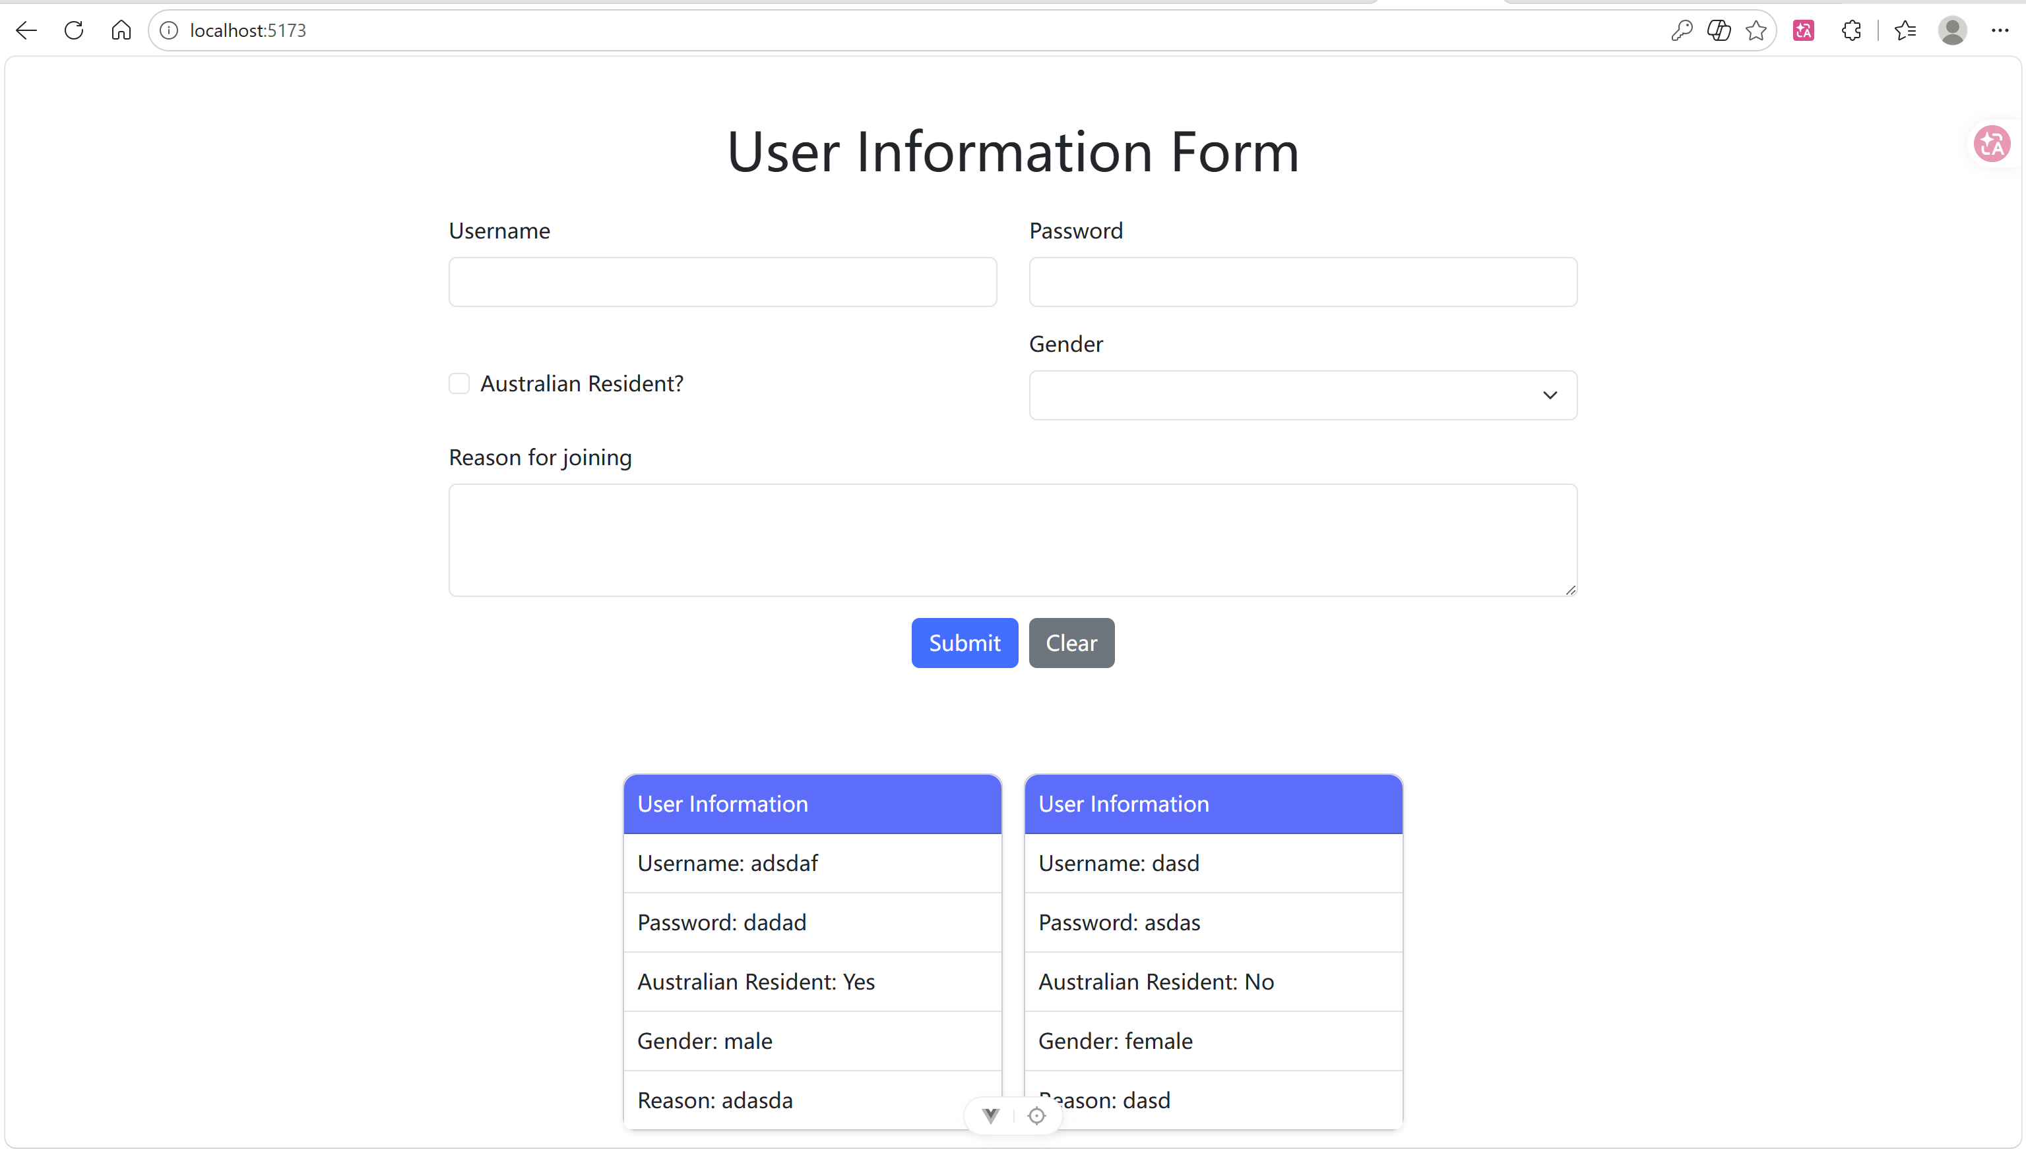
Screenshot 2: screenshots of your front-end demonstrating the form support on different devices. 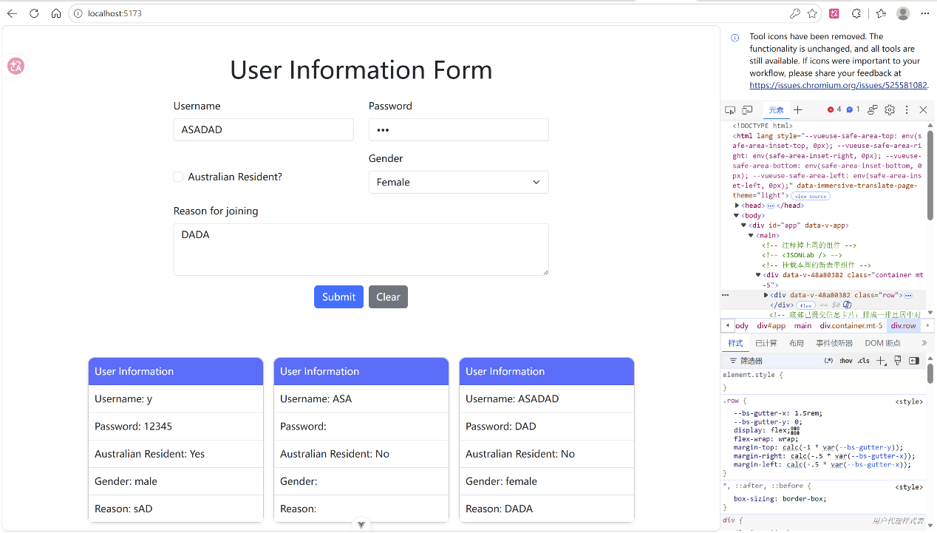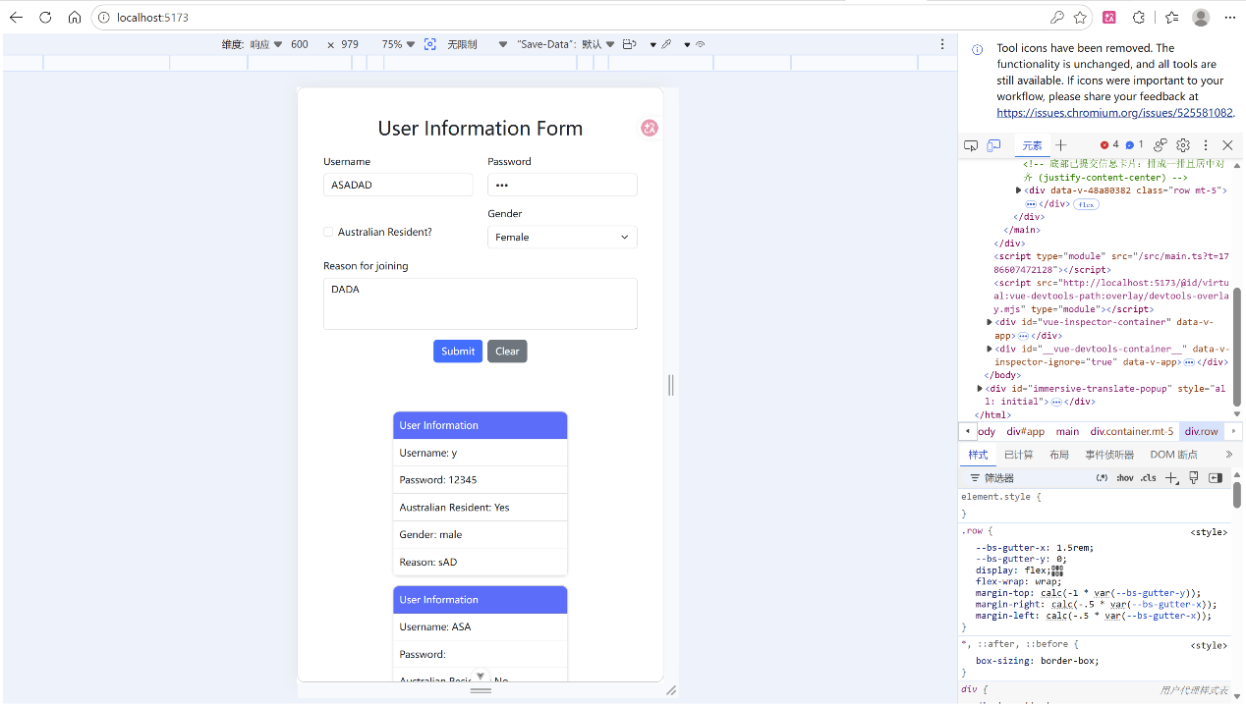
Screenshot 3: a screenshot of the code for implementing the Bootstrap's breakpoints.
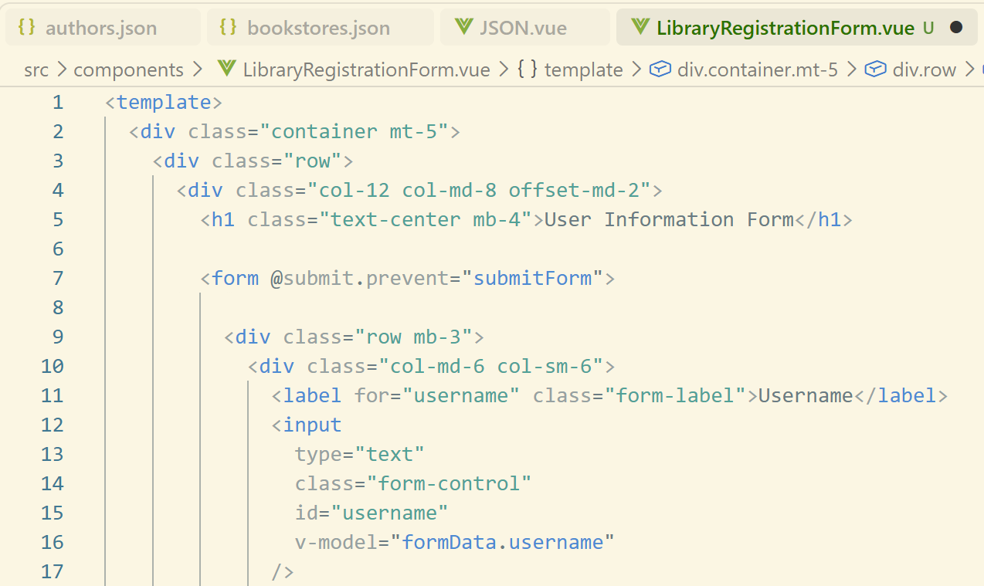
Screenshot 4: a screenshot showing the GitHub commit history with your project update.
